**Project Report**

**On**

“Digit Recognition”

Submitted in the Partial fulfillment of the requirement for the Award of Degree of

**Bachelor of Technology**

in

**COMPUTER SCIENCE & ENGINEERING**

Batch

(2017-2021)



|  |  |
| --- | --- |
| **Submitted to**  Dr. Amarpreet Singh | **Submitted by**  Abhijeet Singh (1701218)  Abhinav Kumar Jha (1701219)  Akash Kumar (1701224)  Deepinder Singh (1701255) |
|  |  |

**DEPARTMENT OF COMPUTER SCIENCE & ENGINEERING**

**Amritsar College of Engineering & Technology, Amritsar**

**(Autonomous college under UGC Act – 1956[2(f) and 12(B)])**

###### ACKNOWLEDGEMENT

This is a humble effort to express our sincere gratitude towards those who have guided and helped me to complete this project.

A project is major milestone during the study period of a student. As such this project was a challenge to us and was an opportunity to prove our caliber. We are highly grateful and obliged to each and every one making me help out of problems being faced by us.

It would not have been possible to see through the undertaken project without the guidance of **Dr. Amarpreet Singh.** It was purely on the basis of their experience and knowledge that we able to clear all the theoretical and technical hurdles during the development phases of this project work.

Last but not the least we are very thankful to our Head of Department **Mr. Vinod Sharma** and all Members of Computer Science Deptt. who gave us an opportunity to face real time problems while fulfilling need of an organization by making projects for them.

**DECLARATION**

We hereby declare that the project work entitled **“Digit Recognition”** is an authentic record of my own work carried out as requirements of Institutional project for the award of degree of B.Tech(CSE), **Amritsar College of Engg. And Technology, Amritsar,** under the guidance of **Dr. Amarpreet Singh**

(Signature of Students)

Abhijeet Singh (1701218)

Abhinav Kumar Jha (1701219)

Akash Kumar (1701224)

Deepinder Singh (1701255)

Certified that the above statement made by the student is correct to the best of our knowledge

and belief.

**Faculty Coordinator**

Dr. Amarpreet Singh

**TABLE OF CONTENT**

|  |  |  |
| --- | --- | --- |
| S.NO | CONTENTS | PAGE NO. |
| 1. | INTRODUCTION TO SUBJECT | 5 |
| 2. | TYPES OF ARTIFICIAL INTELLIGENCE | 10 |
| 3. | INTRODUCTION TO PROJECT | 13 |
| 4.  5. | CODE & OUTPUT  REFERENCES | 15  23 |
|  |  |  |
|  |  |  |

## Introduction to Artificial Intelligence

**What is Artificial intelligence…?**

Artificial intelligence (AI) refers to the simulation of human **intelligence** in machines that are programmed to think like humans and mimic their actions. The term may also be applied to any machine that exhibits traits associated with a human mind such as learning and problem-solving.

**Understanding Artificial Intelligence**

When most people hear the term artificial intelligence, the first thing they usually think of is robots. That's because big-budget films and novels weave stories about human-like machines that wreak havoc on Earth. But nothing could be further from the truth.

Artificial intelligence is based on the principle that human intelligence can be defined in a way that a machine can easily mimic it and execute tasks, from the most simple to those that are even more complex. The goals of artificial intelligence include learning, reasoning, and perception.

As technology advances, previous benchmarks that defined artificial intelligence become outdated. For example, machines that calculate basic functions or recognize text through optimal character recognition are no longer considered to embody artificial intelligence, since this function is now taken for granted as an inherent computer function.

AI is continuously evolving to benefit many different industries. Machines are wired using a cross-disciplinary approach based in mathematics, computer science, linguistics, psychology, and more.

**Why Artificial Intelligence?**

Before Learning about Artificial Intelligence, we should know that what is the importance of AI and why should we learn it. Following are some main reasons to learn about AI:

* With the help of AI, you can create such software or devices which can solve real-world problems very easily and with accuracy such as health issues, marketing, traffic issues, etc.
* With the help of AI, you can create your personal virtual Assistant, such as Cortana, Google Assistant, Siri, etc.
* With the help of AI, you can build such Robots which can work in an environment where survival of humans can be at risk.
* AI opens a path for other new technologies, new devices, and new Opportunities.

**Goals of Artificial Intelligence**

Following are the main goals of Artificial Intelligence:

1. Replicate human intelligence
2. Solve Knowledge-intensive tasks
3. An intelligent connection of perception and action
4. Building a machine which can perform tasks that requires human intelligence such as:
   * Proving a theorem
   * Playing chess
   * Plan some surgical operation
   * Driving a car in traffic
5. Creating some system which can exhibit intelligent behavior, learn new things by itself, demonstrate, explain, and can advise to its user.

**What Comprises to Artificial Intelligence?**

Artificial Intelligence is not just a part of computer science even it's so vast and requires lots of other factors which can contribute to it. To create the AI first we should know that how intelligence is composed, so the Intelligence is an intangible part of our brain which is a combination of **Reasoning, learning, problem-solving perception, language understanding, etc**.

To achieve the above factors for a machine or software Artificial Intelligence requires the following discipline:

* Mathematics
* Biology
* Psychology
* Sociology
* Computer Science
* Neurons Study
* Statistics

**Advantages of Artificial Intelligence:**

Following are some main advantages of Artificial Intelligence:

* **High Accuracy with less errors:** AI machines or systems are prone to less errors and high accuracy as it takes decisions as per pre-experience or information.
* **High-Speed:** AI systems can be of very high-speed and fast-decision making, because of that AI systems can beat a chess champion in the Chess game.
* **High reliability:** AI machines are highly reliable and can perform the same action multiple times with high accuracy.
* **Useful for risky areas:** AI machines can be helpful in situations such as defusing a bomb, exploring the ocean floor, where to employ a human can be risky.
* **Digital Assistant:** AI can be very useful to provide digital assistant to the users such as AI technology is currently used by various E-commerce websites to show the products as per customer requirement.
* **Useful as a public utility:** AI can be very useful for public utilities such as a self-driving car which can make our journey safer and hassle-free, facial recognition for security purpose, Natural language processing to communicate with the human in human-language, etc.

**Disadvantages of Artificial Intelligence:**

Every technology has some disadvantages, and thesame goes for Artificial intelligence. Being so advantageous technology still, it has some disadvantages which we need to keep in our mind while creating an AI system. Following are the disadvantages of AI:

* **High Cost:** The hardware and software requirement of AI is very costly as it requires lots of maintenance to meet current world requirements.
* **Can't think out of the box:** Even we are making smarter machines with AI, but still they cannot work out of the box, as the robot will only do that work for which they are trained, or programmed.
* **No feelings and emotions:** AI machines can be an outstanding performer, but still it does not have the feeling so it cannot make any kind of emotional attachment with human, and may sometime be harmful for users if the proper care is not taken.
* **Increase dependency on machines:** With the increment of technology, people are getting more dependent on devices and hence they are losing their mental capabilities.
* **No Original Creativity:** As humans are so creative and can imagine some new ideas but still AI machines cannot beat this power of human intelligence and cannot be creative and imaginative.

**Prerequisite:**

Before learning about Artificial Intelligence, you must have the fundamental knowledge of following so that you can understand the concepts easily:

* Any computer language such as C, C++, Java, Python, etc.(knowledge of Python will be an advantage)
* Knowledge of essential Mathematics such as derivatives, probability theory, etc.

**Application of AI:**

Artificial Intelligence has various applications in today's society. It is becoming essential for today's time because it can solve complex problems with an efficient way in multiple industries, such as Healthcare, entertainment, finance, education, etc. AI is making our daily life more comfortable and fast.

Following are some sectors which have the application of Artificial Intelligence:

**1. AI in Astronomy**

* Artificial Intelligence can be very useful to solve complex universe problems. AI technology can be helpful for understanding the universe such as how it works, origin, etc.

**2. AI in Healthcare**

* In the last, five to ten years, AI becoming more advantageous for the healthcare industry and going to have a significant impact on this industry.
* Healthcare Industries are applying AI to make a better and faster diagnosis than humans. AI can help doctors with diagnoses and can inform when patients are worsening so that medical help can reach to the patient before hospitalization.

**3. AI in Gaming**

* AI can be used for gaming purpose. The AI machines can play strategic games like chess, where the machine needs to think of a large number of possible places.

**4. AI in Finance**

* AI and finance industries are the best matches for each other. The finance industry is implementing automation, chatbot, adaptive intelligence, algorithm trading, and machine learning into financial processes.

**5. AI in Data Security**

* The security of data is crucial for every company and cyber-attacks are growing very rapidly in the digital world. AI can be used to make your data more safe and secure. Some examples such as AEG bot, AI2 Platform,are used to determine software bug and cyber-attacks in a better way.

**6. AI in Social Media**

* Social Media sites such as Facebook, Twitter, and Snapchat contain billions of user profiles, which need to be stored and managed in a very efficient way. AI can organize and manage massive amounts of data. AI can analyze lots of data to identify the latest trends, hashtag, and requirement of different users.

**7. AI in Travel & Transport**

* AI is becoming highly demanding for travel industries. AI is capable of doing various travel related works such as from making travel arrangement to suggesting the hotels, flights, and best routes to the customers. Travel industries are using AI-powered chatbots which can make human-like interaction with customers for better and fast response.

**8. AI in Automotive Industry**

* Some Automotive industries are using AI to provide virtual assistant to their user for better performance. Such as Tesla has introduced TeslaBot, an intelligent virtual assistant.
* Various Industries are currently working for developing self-driven cars which can make your journey more safe and secure.

**9. AI in Robotics:**

* Artificial Intelligence has a remarkable role in Robotics. Usually, general robots are programmed such that they can perform some repetitive task, but with the help of AI, we can create intelligent robots which can perform tasks with their own experiences without pre-programmed.
* Humanoid Robots are best examples for AI in robotics, recently the intelligent Humanoid robot named as Erica and Sophia has been developed which can talk and behave like humans.

**10. AI in Entertainment**

* We are currently using some AI based applications in our daily life with some entertainment services such as Netflix or Amazon. With the help of ML/AI algorithms, these services show the recommendations for programs or shows.

**11. AI in Agriculture**

* Agriculture is an area which requires various resources, labor, money, and time for best result. Now a day's agriculture is becoming digital, and AI is emerging in this field. Agriculture is applying AI as agriculture robotics, solid and crop monitoring, predictive analysis. AI in agriculture can be very helpful for farmers.

**12. AI in E-commerce**

* AI is providing a competitive edge to the e-commerce industry, and it is becoming more demanding in the e-commerce business. AI is helping shoppers to discover associated products with recommended size, color, or even brand.

**13. AI in education:**

* AI can automate grading so that the tutor can have more time to teach. AI chatbot can communicate with students as a teaching assistant.
* AI in the future can be work as a personal virtual tutor for students, which will be accessible easily at any time and any place.

**History of Artificial Intelligence:**

Artificial Intelligence is not a new word and not a new technology for researchers. This technology is much older than you would imagine. Even there are the myths of Mechanical men in Ancient Greek and Egyptian Myths. Following are some milestones in the history of AI which defines the journey from the AI generation to till date development.

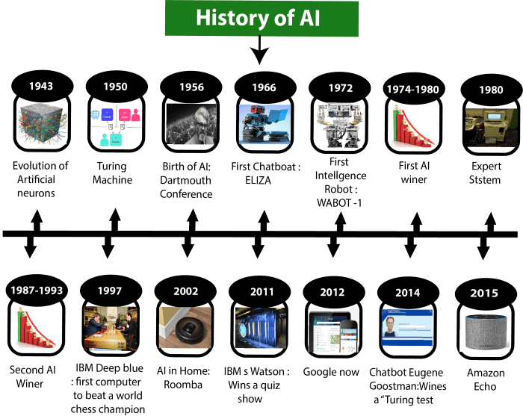

**TYPES OF**

**ARTIFICIAL INTELLIGENCE**

Artificial Intelligence can be divided in various types, there are mainly two types of main categorization which are based on capabilities and based on functionally of AI. Following is flow diagram which explain the types of AI.

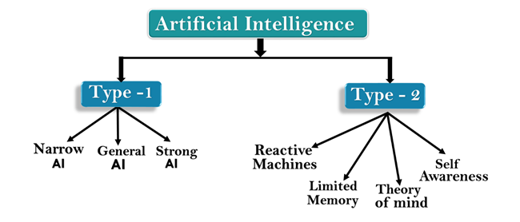

**AI type-1: Based on Capabilities**

**1. Weak AI or Narrow AI:**

* Narrow AI is a type of AI which is able to perform a dedicated task with intelligence.The most common and currently available AI is Narrow AI in the world of Artificial Intelligence.
* Narrow AI cannot perform beyond its field or limitations, as it is only trained for one specific task. Hence it is also termed as weak AI. Narrow AI can fail in unpredictable ways if it goes beyond its limits.
* Apple Siriis a good example of Narrow AI, but it operates with a limited pre-defined range of functions.
* IBM's Watson supercomputer also comes under Narrow AI, as it uses an Expert system approach combined with Machine learning and natural language processing.
* Some Examples of Narrow AI are playing chess, purchasing suggestions on e-commerce site, self-driving cars, speech recognition, and image recognition.

**2. General AI:**

* General AI is a type of intelligence which could perform any intellectual task with efficiency like a human.
* The idea behind the general AI to make such a system which could be smarter and think like a human by its own.
* Currently, there is no such system exist which could come under general AI and can perform any task as perfect as a human.
* The worldwide researchers are now focused on developing machines with General AI.
* As systems with general AI are still under research, and it will take lots of efforts and time to develop such systems.

**3. Super AI:**

* Super AI is a level of Intelligence of Systems at which machines could surpass human intelligence, and can perform any task better than human with cognitive properties. It is an outcome of general AI.
* Some key characteristics of strong AI include capability include the ability to think, to reason,solve the puzzle, make judgments, plan, learn, and communicate by its own.
* Super AI is still a hypothetical concept of Artificial Intelligence. Development of such systems in real is still world changing task.

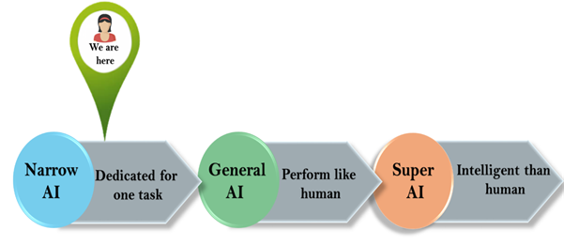

**Artificial Intelligence type-2: Based on functionality**

**1. Reactive Machines**

* Purely reactive machines are the most basic types of Artificial Intelligence.
* Such AI systems do not store memories or past experiences for future actions.
* These machines only focus on current scenarios and react on it as per possible best action.
* IBM's Deep Blue system is an example of reactive machines.
* Google's AlphaGo is also an example of reactive machines.

**2. Limited Memory**

* Limited memory machines can store past experiences or some data for a short period of time.
* These machines can use stored data for a limited time period only.
* Self-driving cars are one of the best examples of Limited Memory systems. These cars can store recent speed of nearby cars, the distance of other cars, speed limit, and other information to navigate the road.

**3. Theory of Mind**

* Theory of Mind AI should understand the human emotions, people, beliefs, and be able to interact socially like humans.
* This type of AI machines are still not developed, but researchers are making lots of efforts and improvement for developing such AI machines.

**4. Self-Awareness**

* Self-awareness AI is the future of Artificial Intelligence. These machines will be super intelligent, and will have their own consciousness, sentiments, and self-awareness.
* These machines will be smarter than human mind.
* Self-Awareness AI does not exist in reality still and it is a hypothetical concept.

**INTRODUCTION TO**

**DIGIT RECOGNITION**

In a computer vision system, digits recognition is a complex task that is central to a variety of emerging applications. It has been widely used by machine learning and computer vision researchers for implementing practical applications like computerized bank check numbers reading. In this study, we implemented a multi-layer fully connected neural network with one hidden layer for digits recognition. The testing has been conducted from publicly available MNIST handwritten database. From the MNIST database, we extracted 28,000 digits images for training and 14,000 digits images for performing the test. Our multi-layer artificial neural network has an accuracy of 99.60% with test performance.

Digits recognition becomes increasingly important in the modern world due to its practical applications in our daily life. In recent years, numerous recognition systems have been introduced within many applications where high classification efficiency is required. It helps us to solve more complex problems and makes ease our tasks. An early stage digit recognition was presented for zip code recognition. Automatic processing of bank checks, the postal address is widely used applications of digit recognition. A human being has been proffered a common bias to distinguish numerous objects with variations such as digits, letters, faces, voice.

However, executing a computerized system to do certain kinds of duties is a very complex and challenging matter. In addition, pattern identification is the fundamental ingredient of a computer vision and artificial intelligence based system. In this paper, we implemented an artificial neural network (ANN) and trained it to recognize handwritten digits from 0 to 9. A node in a neural network can be understood as a neuron in the brain. Each node is connected to other nodes through weights which are adjusted in the machine learning process during training. A value is calculated for each node based on values and ways of previous nodes. This process is called forward propagation.

The final output of the network is associated with the target output, then weights are calibrated to minimize a transgression function describing whether the network guessed correctly. This process is called back propagation. To add more complexity and accuracy in the neural networks, the networks have multiple layers. In between a completely connected neural network, there are some multiple layers exist, namely input, output, and hidden layers. In a fully connected neural network nodes in each layer are connected to the nodes and the layers before and after them.

**DATASET DESCRIPTION**

We have used MNIST dataset for our proposed digits recognition with ANN approach. The dataset contains thousands of labelled images of handwritten digits written by numerous person. We extracted 42,000 samples to conduct our experiment. It is pre-divided into training, which is 28,000, and test, which is 14,000 images. These images are low resolution, just 28-by-28 pixels in grayscale, also note they are properly segmented (as shown in Fig.).

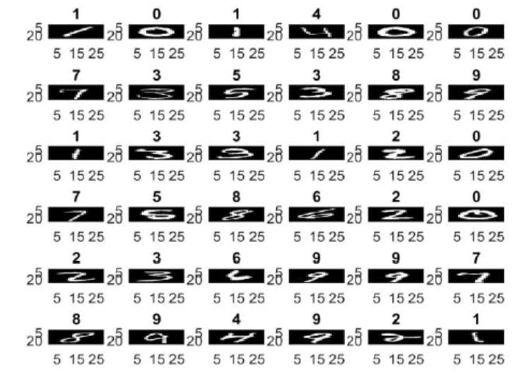

That means each image contains exactly one digit. When we are working with images, we used the raw pixels as features. That is because extracting useful features from images, like texture and shapes, is hard and no feature engineering required. Now, a 28-by28 pixels image has 784 pixels, so we have 784 features. Here, we are using the flattened representation of the image. To flatten image means to convert it from a 2D array to 1D array by unstacking the rows and lining them up. That is why we had to reshape the array to display it in Fig..

**SOURCE CODE**

In [0]:

**import** **numpy** **as** **np**

**import** **matplotlib.pyplot** **as** **plt**

**import** **keras**

**from** **keras.datasets** **import** mnist

**from** **keras.models** **import** Sequential

**from** **keras.layers** **import** Dense

**from** **keras.utils** **import** to_categorical

**from** **keras.preprocessing** **import** image

In [3]:

(x_train, y_train), (x_test, y_test) = mnist.load_data()

Downloading data from https://s3.amazonaws.com/img-datasets/mnist.npz

11493376/11490434 [==============================] - 0s 0us/step

In [4]:

x_train.shape

Out[4]:

(60000, 28, 28)

In [5]:

x_test.shape

Out[5]:

(10000, 28, 28)

In [6]:

y_train.shape

Out[6]:

(60000,)

In [7]:

y_test.shape

Out[7]:

(10000,)

In [0]:

**def** plot_img(img):

plt.imshow(img.reshape(28,28), cmap="gray")

In [25]:

plot_img(x_train[1002])

print("Image is : " , y_train[1002])

Image is : 1

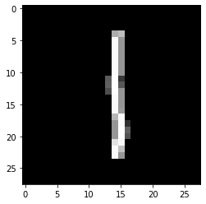

**Model Building**

In [30]:

x_train.shape

Out[30]:

(60000, 28, 28)

In [0]:

x_train = x_train.reshape(60000, 784)

x_test = x_test.reshape(10000, 784)

In [32]:

x_train.shape

Out[32]:

(60000, 784)

In [33]:

x_test.shape

Out[33]:

(10000, 784)

In [0]:

model = Sequential()

model.add( Dense(units=32, activation='relu', input_shape = (784,)) ) *# input_shape only for first layer*

model.add( Dense(units=64, activation='relu' ))

model.add( Dense(units=128, activation = 'relu'))

model.add( Dense(units=32, activation = 'relu'))

model.add( Dense(units=10, activation='softmax')) *# final softmax = > probabilities*

In [36]:

model.summary()

Model: "sequential_1"

_________________________________________________________________

Layer (type) Output Shape Param #

=================================================================

dense_1 (Dense) (None, 32) 25120

_________________________________________________________________

dense_2 (Dense) (None, 64) 2112

_________________________________________________________________

dense_3 (Dense) (None, 128) 8320

_________________________________________________________________

dense_4 (Dense) (None, 32) 4128

_________________________________________________________________

dense_5 (Dense) (None, 10) 330

=================================================================

Total params: 40,010

Trainable params: 40,010

Non-trainable params: 0

_________________________________________________________________

In [0]:

*# "adam"/"sgd"/"rmsprop"*

model.compile(optimizer="adam", loss="categorical_crossentropy", metrics=['accuracy'])

In [38]:

y_train.shape

Out[38]:

(60000,)

In [0]:

y_train = to_categorical(y_train)

y_test = to_categorical(y_test)

In [41]:

y_train.shape

Out[41]:

(60000, 10)

In [42]:

y_test.shape

Out[42]:

(10000, 10)

In [43]:

hist = model.fit(x=x_train, y= y_train, batch_size=32,epochs = 10, validation_data=(x_test, y_test) )

Train on 60000 samples, validate on 10000 samples

Epoch 1/10

60000/60000 [==============================] - 4s 65us/step - loss: 0.6172 - accuracy: 0.8299 - val_loss: 0.3001 - val_accuracy: 0.9175

Epoch 2/10

60000/60000 [==============================] - 3s 57us/step - loss: 0.2454 - accuracy: 0.9300 - val_loss: 0.2149 - val_accuracy: 0.9381

Epoch 3/10

60000/60000 [==============================] - 3s 53us/step - loss: 0.1899 - accuracy: 0.9456 - val_loss: 0.2000 - val_accuracy: 0.9437

Epoch 4/10

60000/60000 [==============================] - 3s 53us/step - loss: 0.1624 - accuracy: 0.9536 - val_loss: 0.1737 - val_accuracy: 0.9545

Epoch 5/10

60000/60000 [==============================] - 3s 54us/step - loss: 0.1443 - accuracy: 0.9589 - val_loss: 0.1554 - val_accuracy: 0.9592

Epoch 6/10

60000/60000 [==============================] - 3s 57us/step - loss: 0.1264 - accuracy: 0.9635 - val_loss: 0.1566 - val_accuracy: 0.9588

Epoch 7/10

60000/60000 [==============================] - 3s 55us/step - loss: 0.1198 - accuracy: 0.9659 - val_loss: 0.1384 - val_accuracy: 0.9627

Epoch 8/10

60000/60000 [==============================] - 3s 54us/step - loss: 0.1122 - accuracy: 0.9682 - val_loss: 0.1514 - val_accuracy: 0.9571

Epoch 9/10

60000/60000 [==============================] - 3s 54us/step - loss: 0.1024 - accuracy: 0.9702 - val_loss: 0.1501 - val_accuracy: 0.9610

Epoch 10/10

60000/60000 [==============================] - 3s 54us/step - loss: 0.0966 - accuracy: 0.9728 - val_loss: 0.1755 - val_accuracy: 0.9622

In [44]:

model.evaluate(x_test, y_test)

10000/10000 [==============================] - 0s 23us/step

Out[44]:

[0.17551743202386424, 0.9621999859809875]

In [59]:

plot_img(x_test[5001])

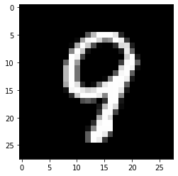

In [0]:

y_pred = model.predict_classes(x_test)

In [61]:

y_pred[5001]

Out[61]:

9

In [63]:

model.predict_classes(x_test[[5000]])

Out[63]:

array([3])

In [65]:

*# this code is custom image.*

img = image.load_img("download.png", grayscale=**True**, target_size=(28,28))

img = np.array(img)

img = img.reshape(1, 784)

prediction = model.predict_classes(img)

print("prediction : ",end=" ")

print(prediction)

prediction : [7]

prediction

array([7], dtype=int64)

**References :**

1. **Books**

* Artificial Intelligence – A Modern Approach (3 Edition)
* Human Compatible – Artificial Intelligence and the Problem of Control
* Superintelligence: Paths, Dangers, Strategies
* Artificial Intelligence for Humans.

1. **Web URLs**

* <https://www.javatpoint.com/artificial-intelligence-tutorial>
* <https://www.tutorialspoint.com/artificial_intelligence/index.htm>
* <https://intellipaat.com/blog/tutorial/artificial-intelligence-tutorial/>